**LAPORAN PRAKTIKUM PEMROGRAMAN BERORIENTASI OBJEK**

“Static Keyword*”*

**

**Anavalis Ridho Abdee Nugroho**

**4523210012**

Dosen Pembimbing :

**Adi Wahyu Pribadi, S.Si., M.Kom.**

**FAKULTAS TEKNIK**

**UNIVERSITAS PANCASILA**

**JAKARTA**

**2024**

1. **Source Code book**

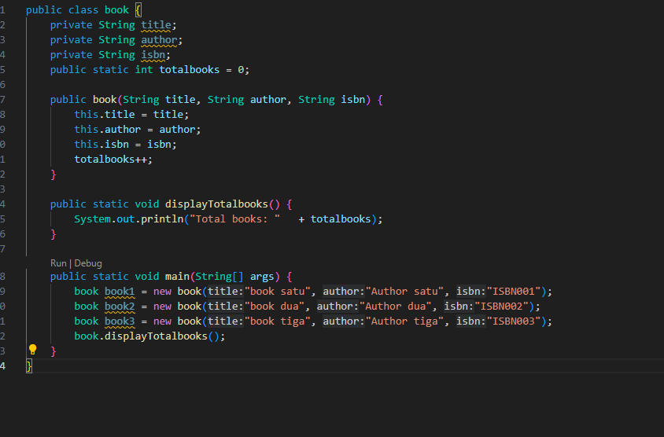

Output

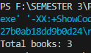

1. **Source Code library**

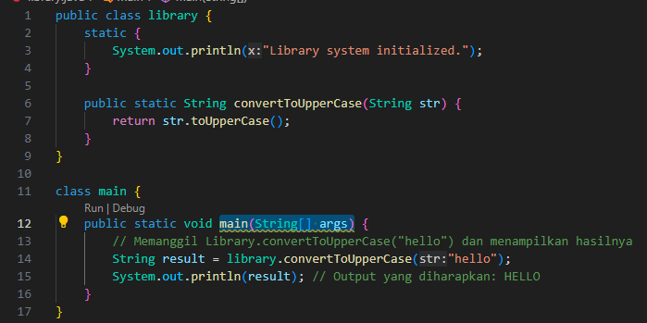

Output



1. **Source Code user**

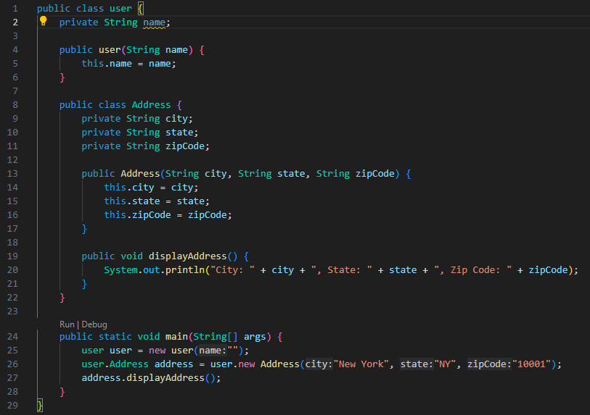

**Output**



1. **Source Code DatabaseConnection**

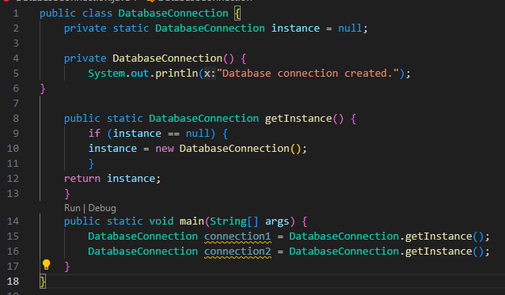

Output



1. **Source Code LibraryManager**

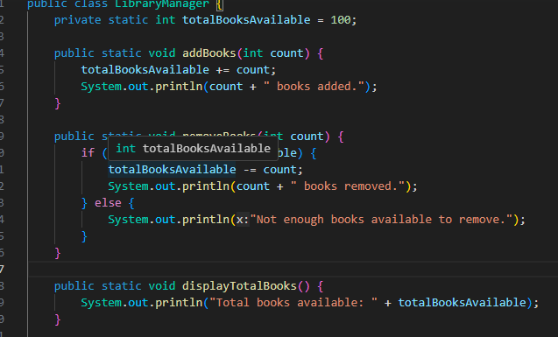

Output

